- \Operation\Strip transfer, unit D\Strip transfer
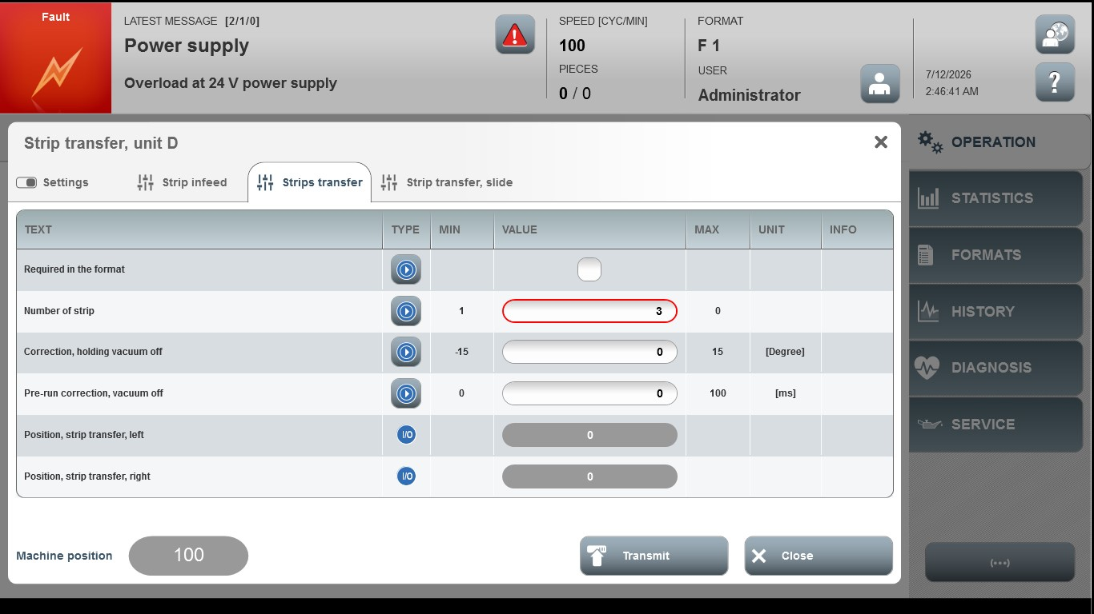

Acceptance criterion | Limits | Pass / Fail: Dev-No. | Date | Initials
Screen matches screenshot | N / A
Number of strip | 1…0
Correction, holding vacuum off | -15…15
Pre-run correction, vacuum off | 0…100

